SKILL-1

Skill-1: Git installation

link: <https://git-scm.com/downloads>

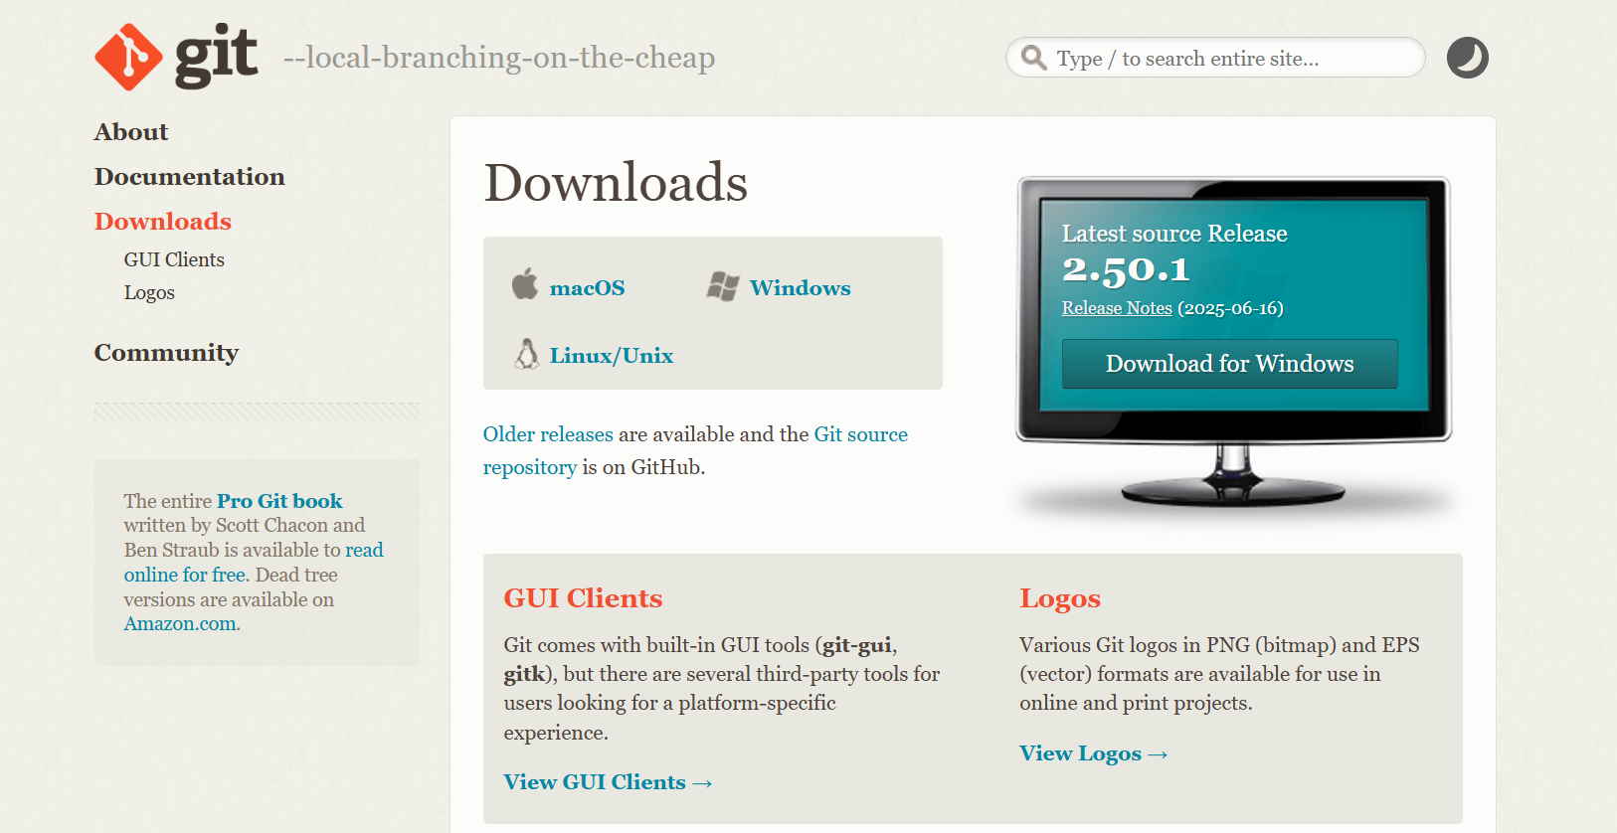

Step1:

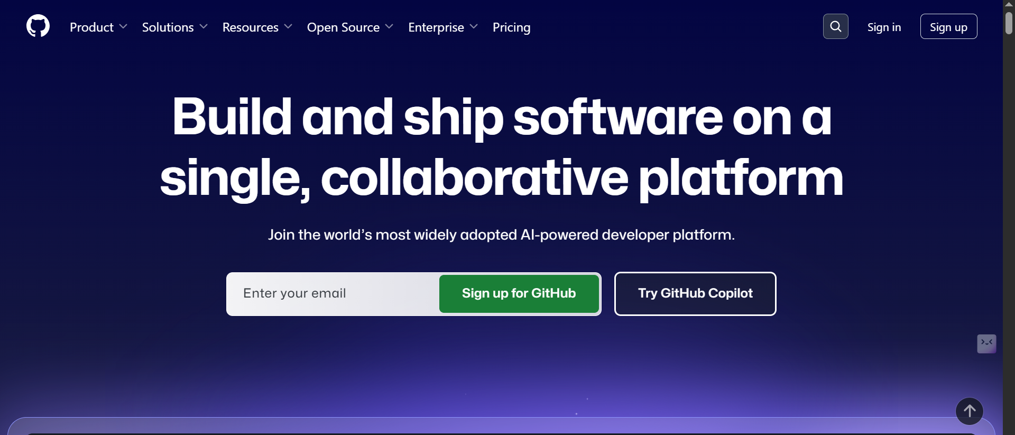

\*First create account go to signup if already exists go to sign in and login to your account

Step2:

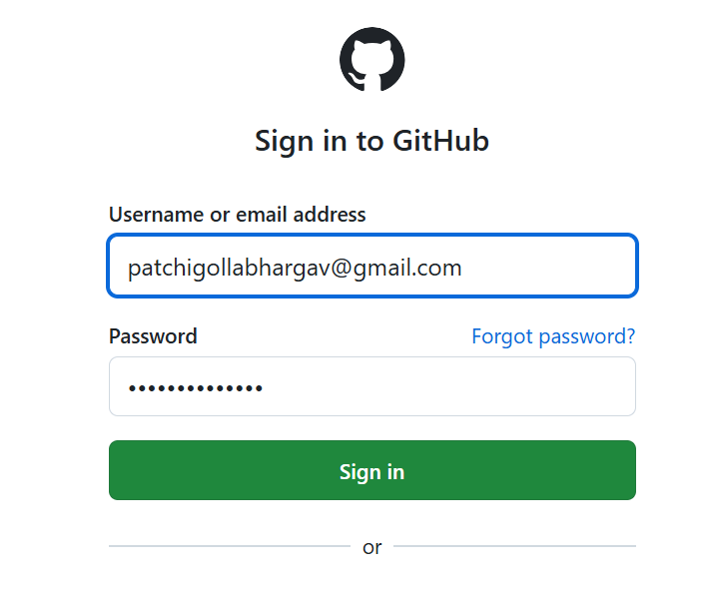

\*Sign in to the account

Step3:

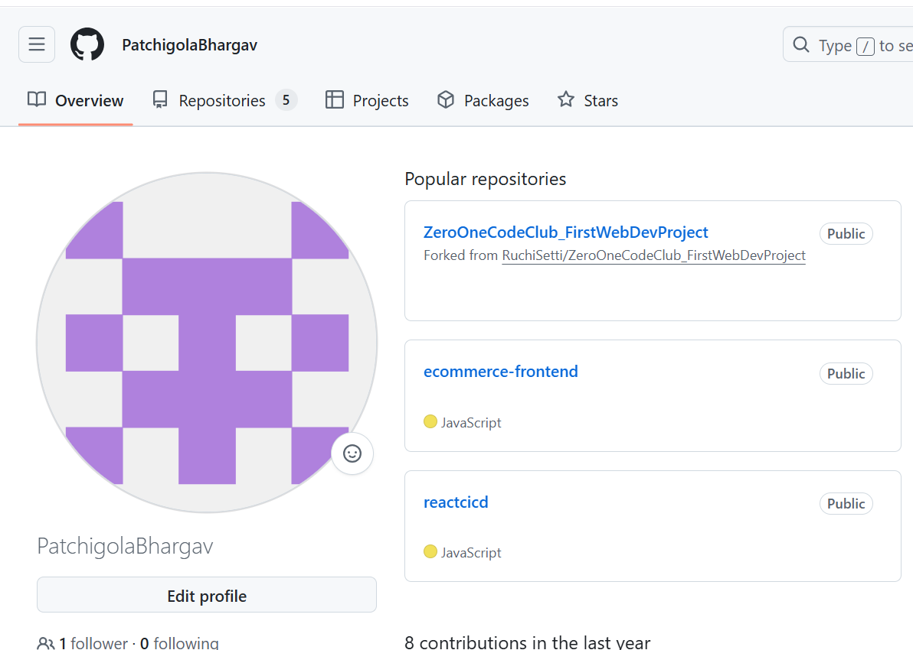

Step4:Git Configuration with github Accout

-configure GitHub Account

git config --global user.name "PatchigolaBhargav"

git config --global user.email [patchigollabhargav@gmail.com](mailto:patchigollabhargav@gmail.com)

